**Shop4All E commerce platform**

**ER-Diagram**

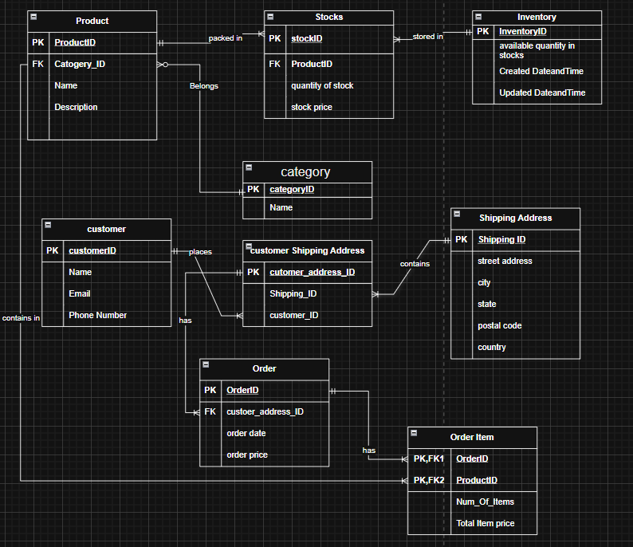

**Relational Schema diagram**

